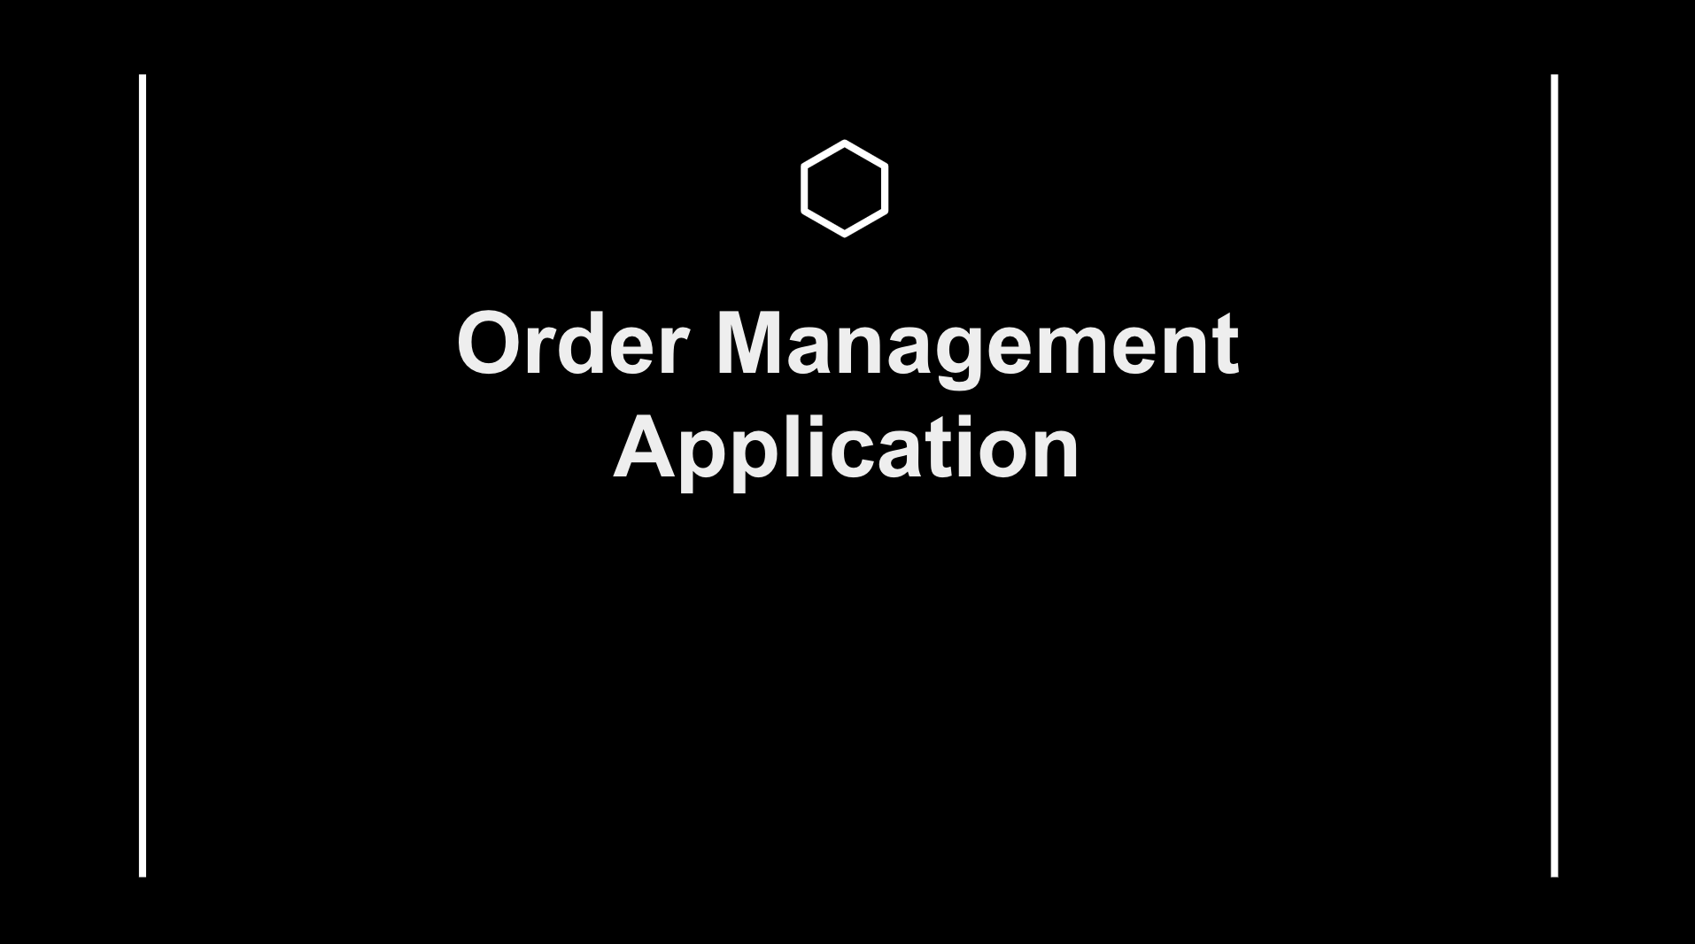

**Abstract :**

The Order Management Application is a Cloud based Salesforce application which allows the user to search for the products they want to buy based on the name, brand and price range of the products along with provision to specify quantity of the products. Depending on the user’s profile, they are permitted to view, create, edit or delete data in the organization. This application also notifies selected users when an order status is updated via in-app notifications and emails.

**Scopes:**

Inscope

Following are the functionalities provided by the application :

There are three categories of the people who would access the application : Sales user, Business user and Support Team. Each of these would have some exclusive privileges.

1. The Sales user can :
2. Can Manage upto 5 Accounts and can view the data related to its Accounts only.
3. Create new Orders.
4. Search for the products after creating an Order.
5. Specify the quantity of each product and discount as well.
6. Remove the selected products from the list before booking.
7. View the bookings of the orders made by them only.
8. Create invoices for the products and order as well.
9. The Business user can :
10. Can manage upto 2 Sales Users.
11. View the accounts, related contacts, orders and invoices only.
12. Approve the orders booked by the sales user when the order amount is greater than 100000.
13. The Support Team can :
    1. Create/Manage Sales users and Business users.
    2. Assign roles to the created users.
    3. Can view all the data on the application.
    4. Can delete records on the application.

Outscope

The following functionalities have not been covered under the application:

1.The application does not cover the payments of orders.

2. Invoice creation is not automated.

3. Transportation and shipping of products is not covered.

4. Once the Products have been added to the Order, products cannot be changed ,edited or deleted.

**Class Diagram :**

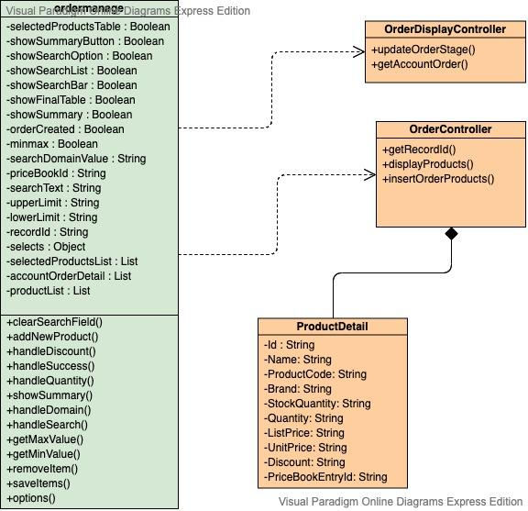

**Sequence Diagram for Sales User :**

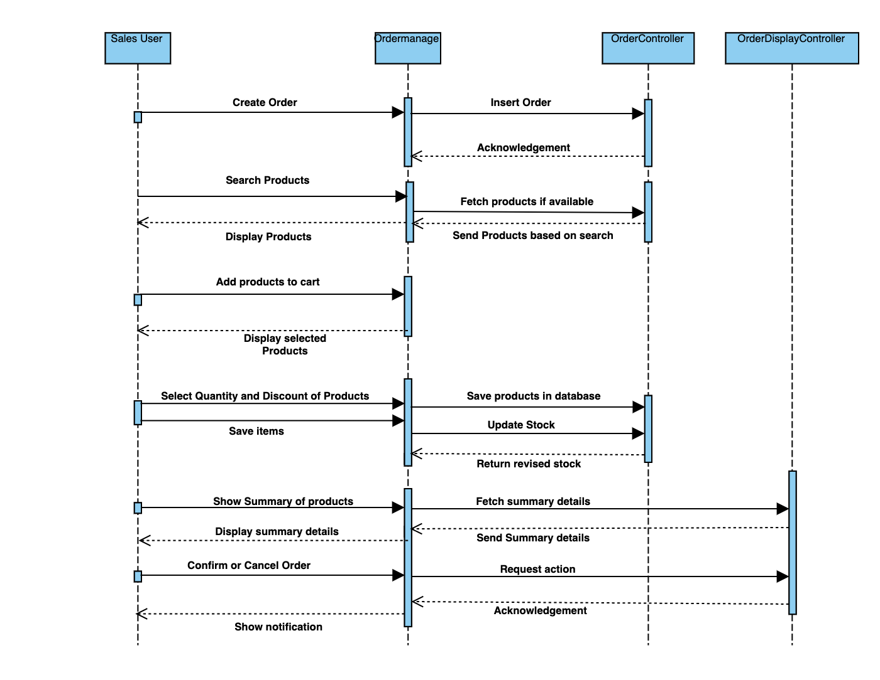

**Activity Diagram for Support Team :**

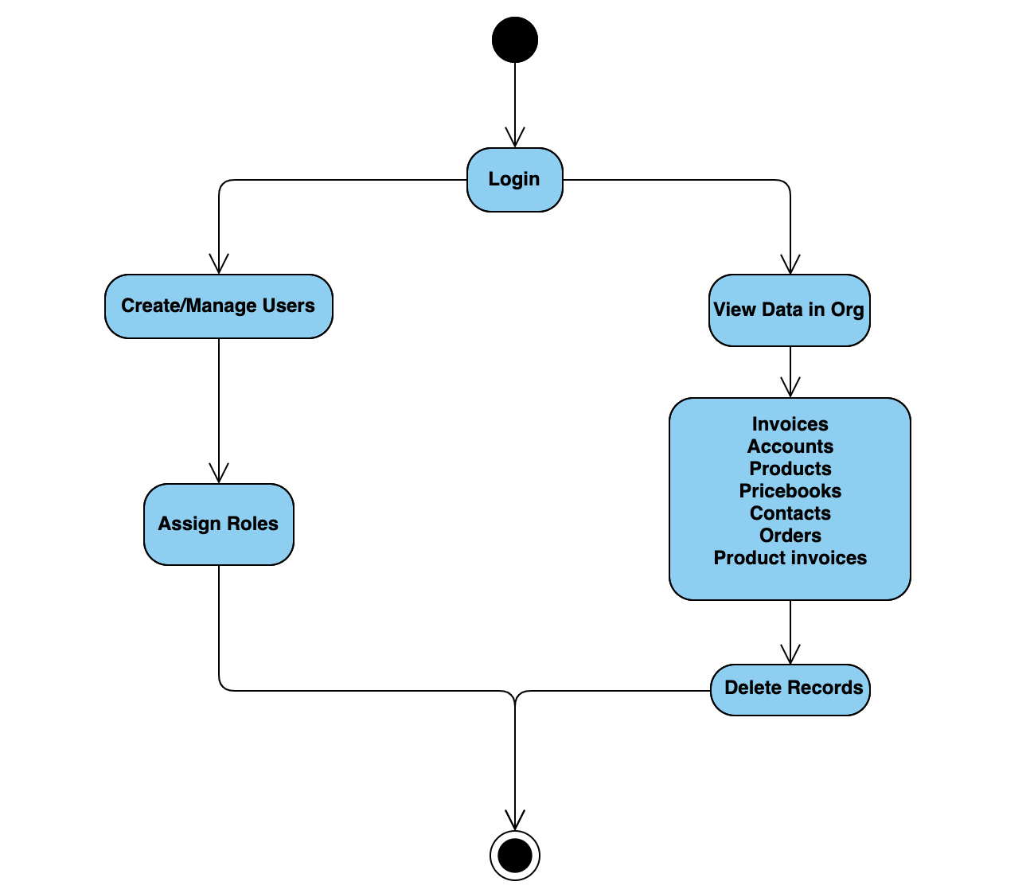

**Activity Diagram for Business User :**

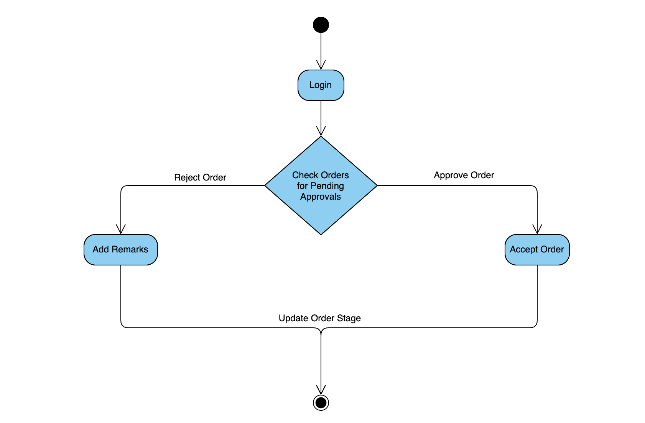

**Activity Diagram for Sales User :**

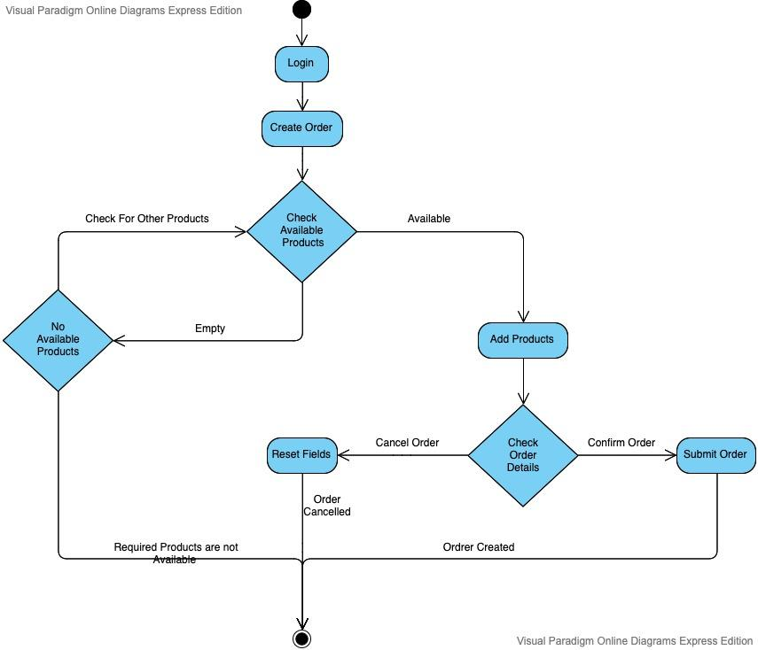

**Flow Chart :**

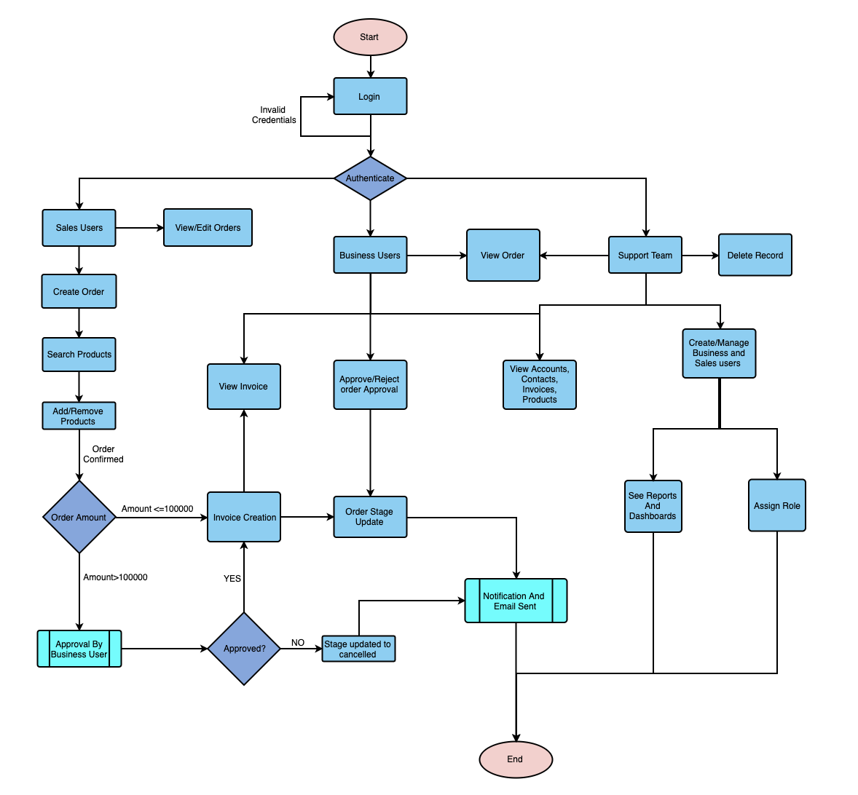

**Use Case Diagram :**

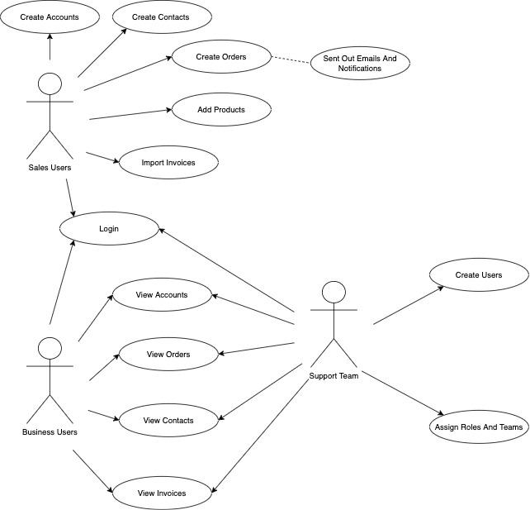

**Wireframes :**

All Orders as Viewed by Support Team:

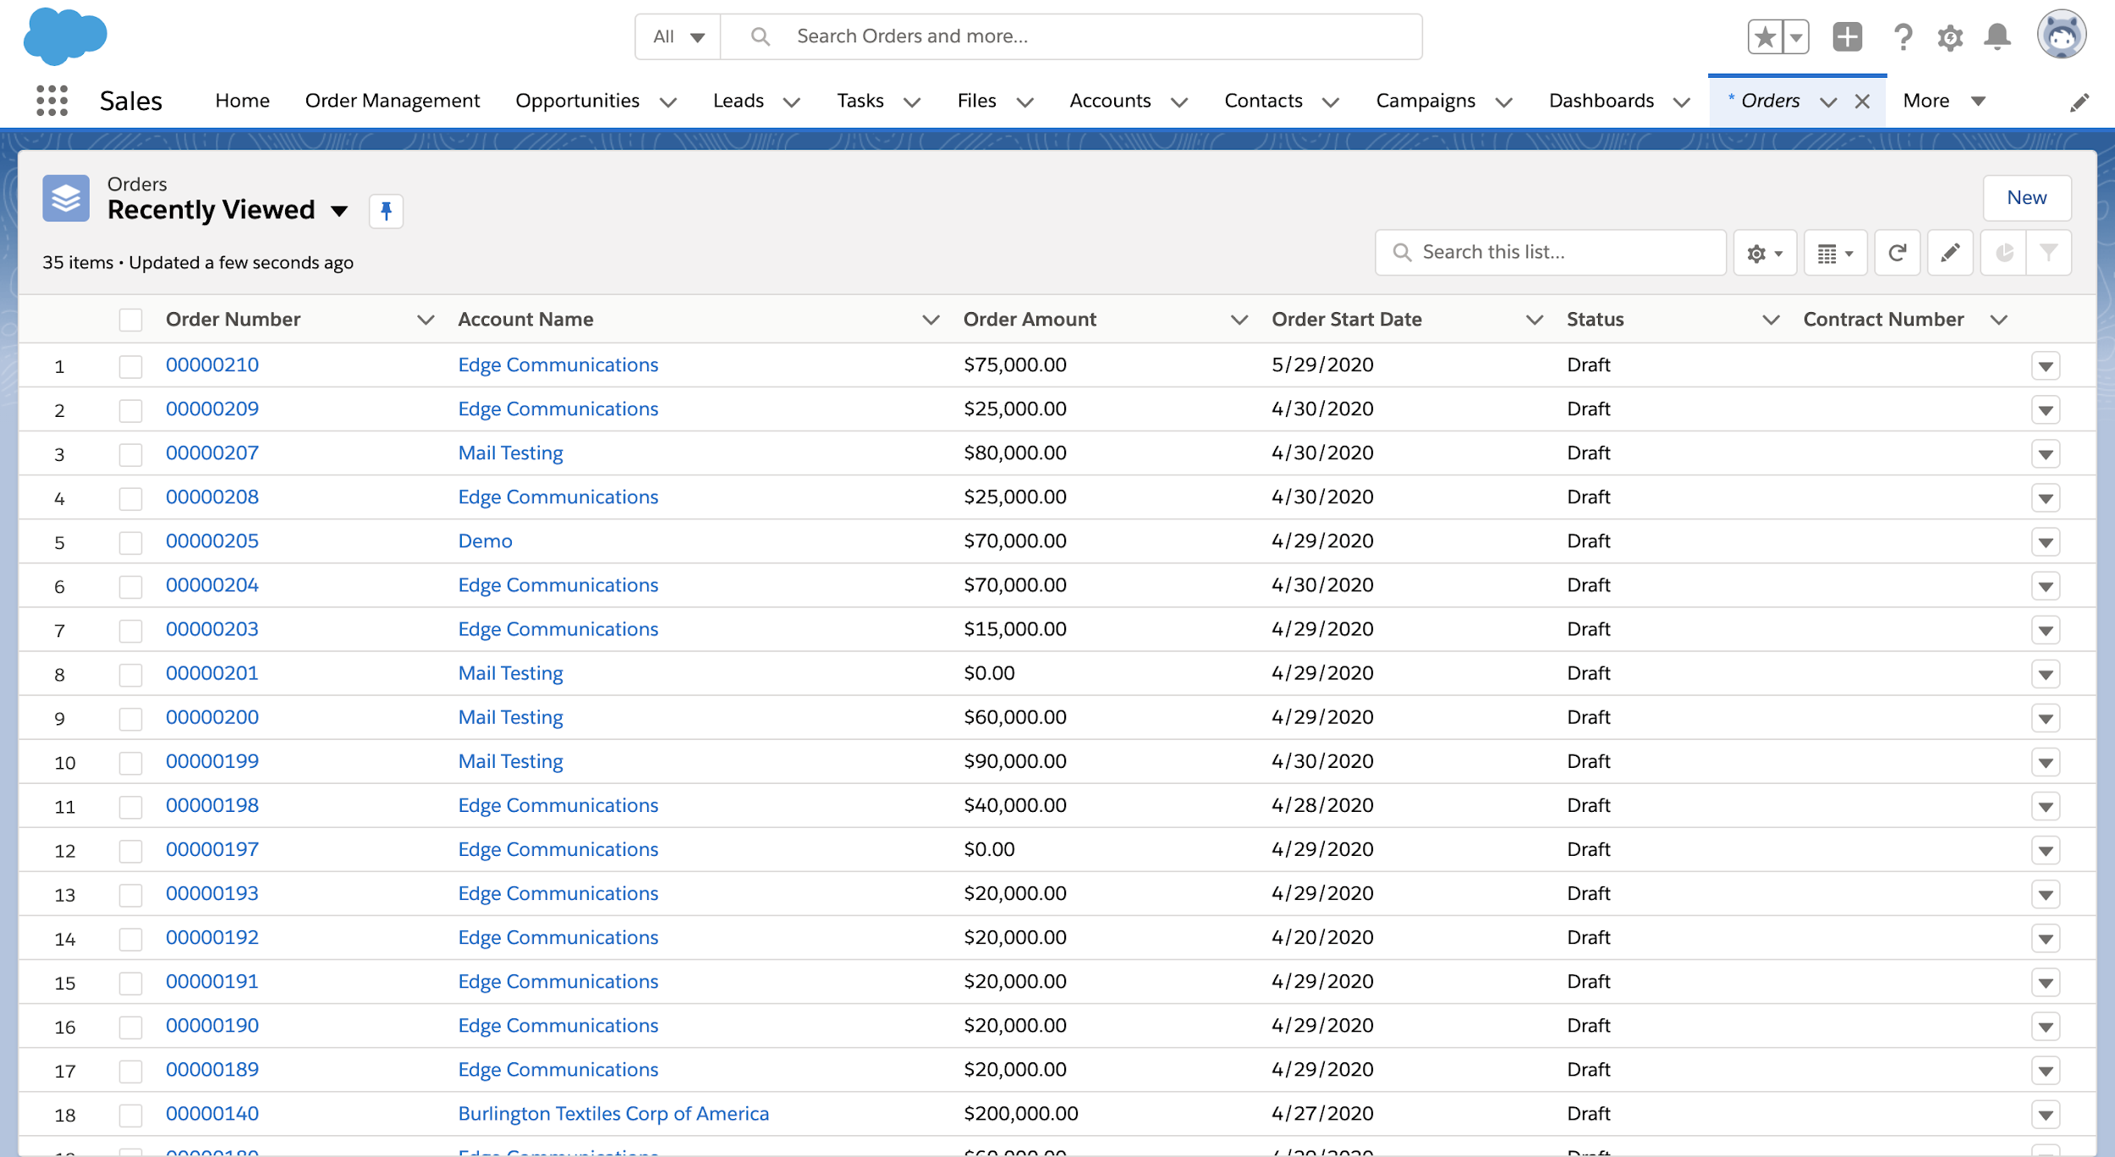

Logging in as a Sales User:

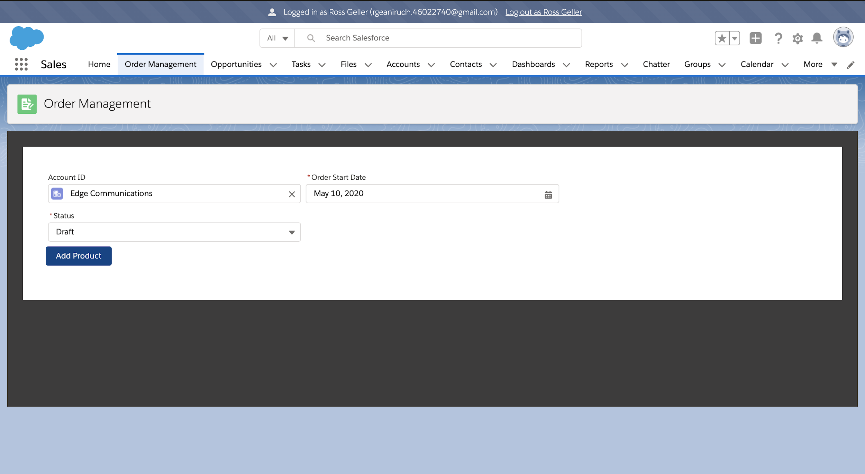

Creating a new Order:

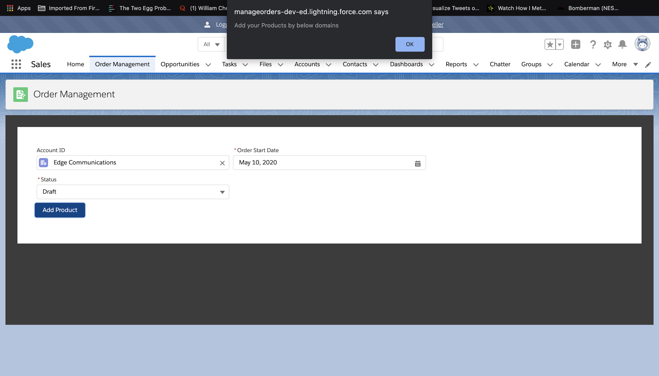

Selecting the option to search products by:

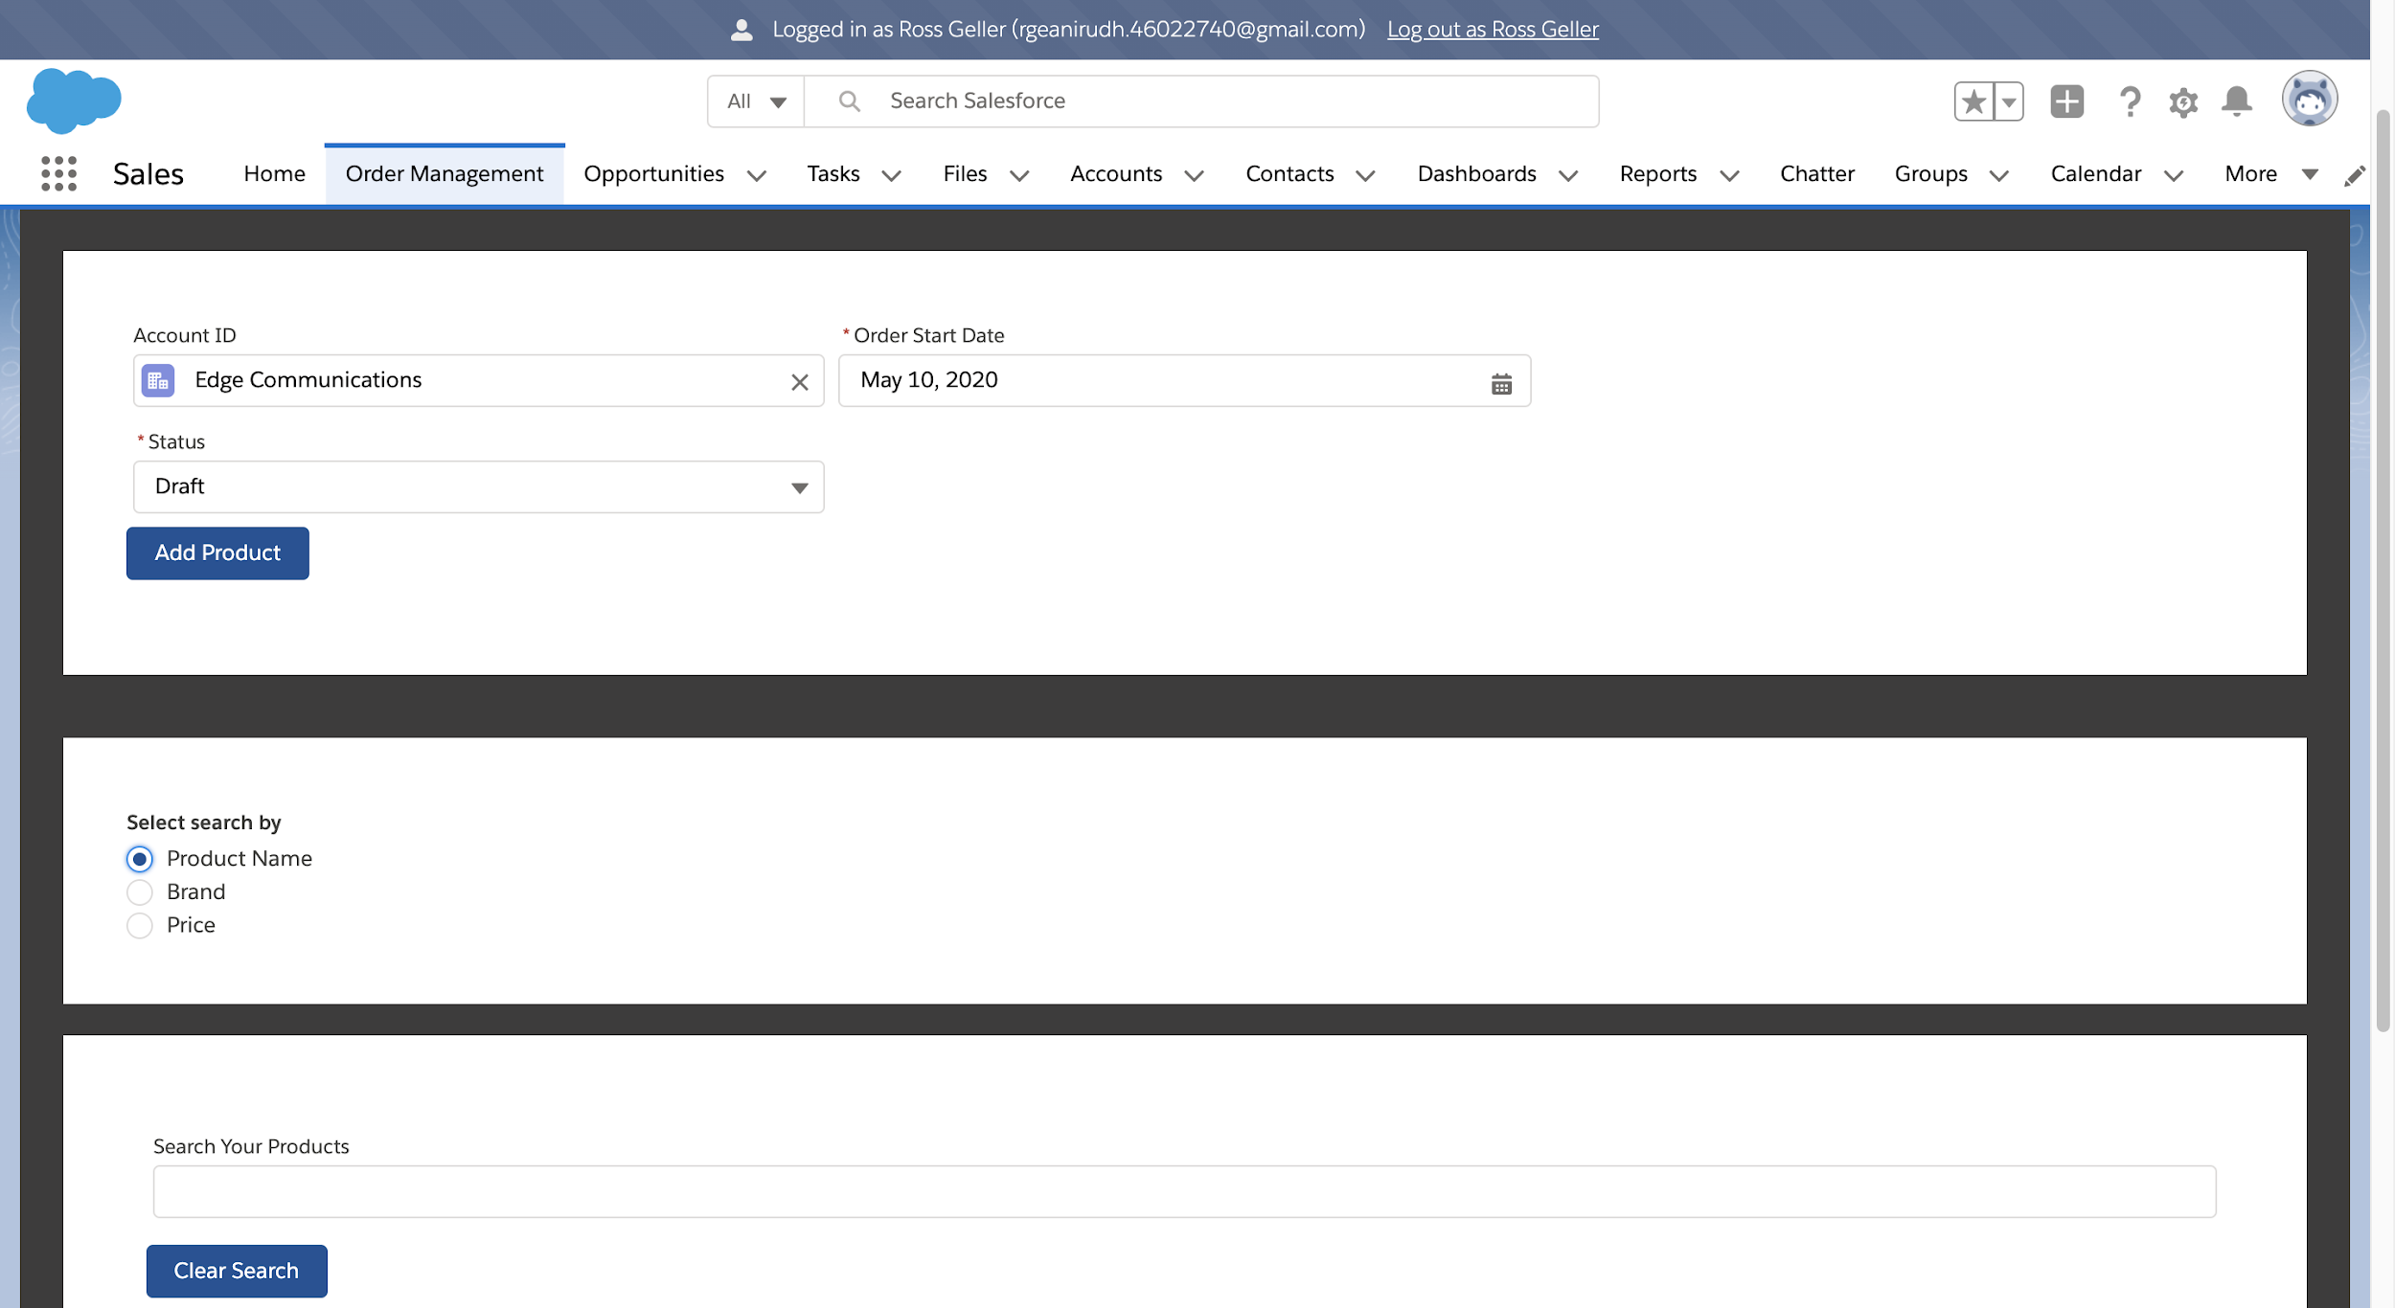

Searching for Products to add:

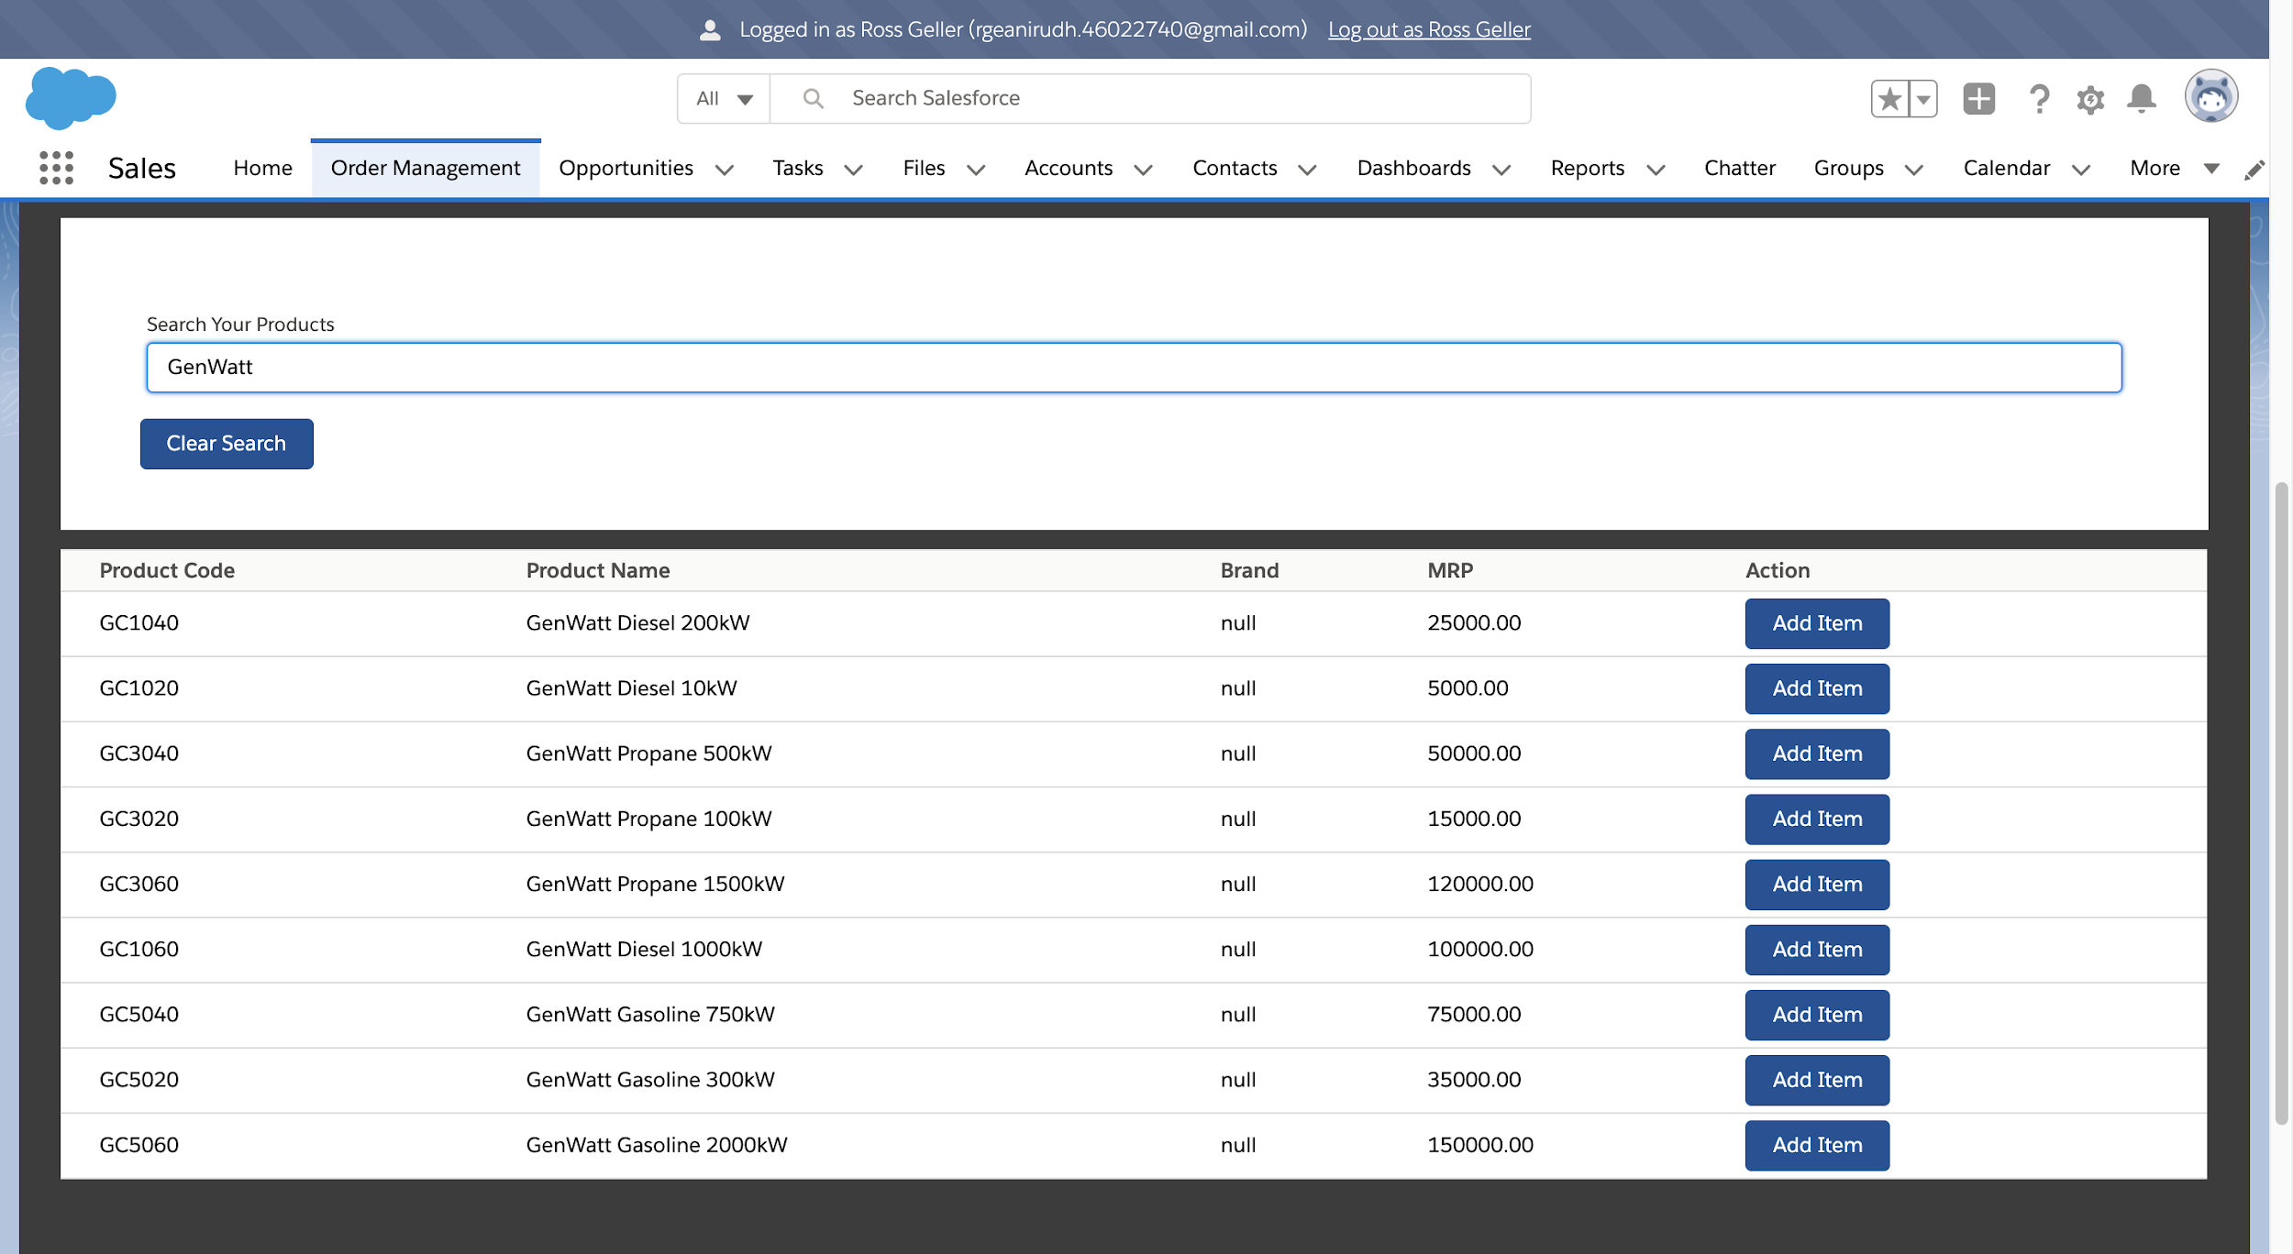

Showing the List of Added Products:

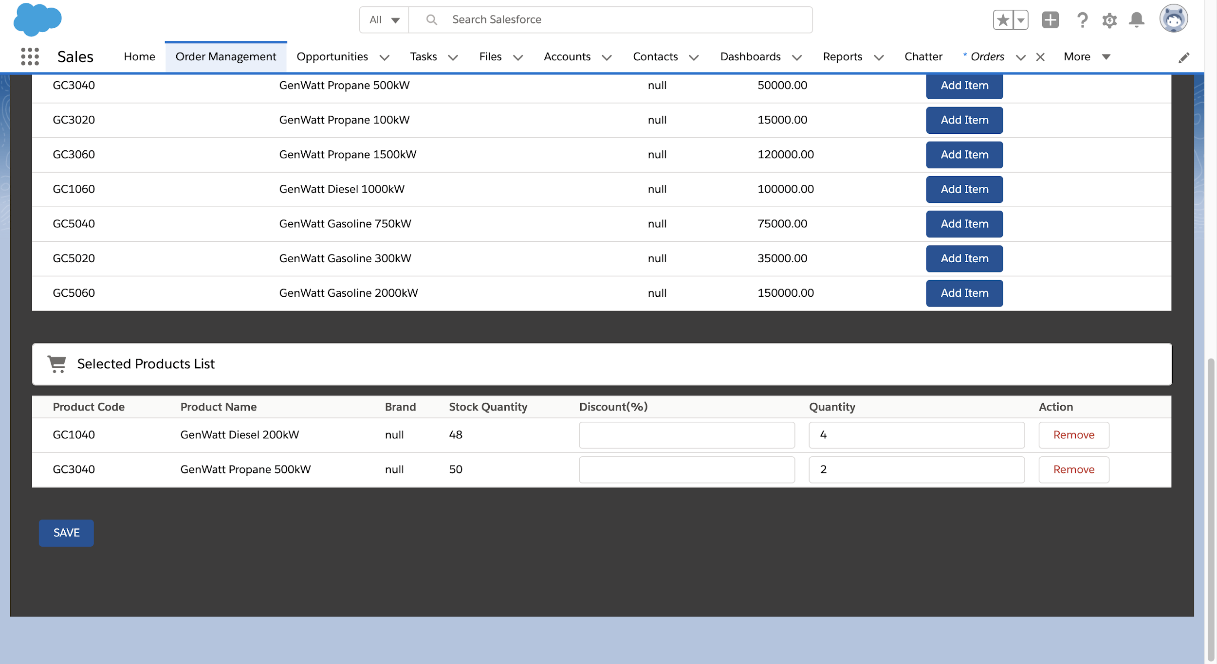

Selecting the Show Summary Button:

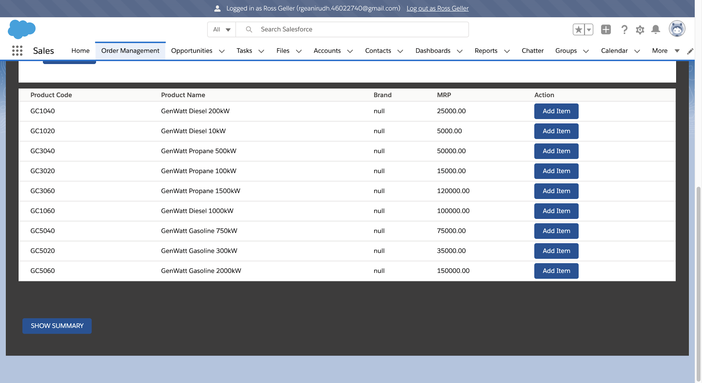

Summary Page:

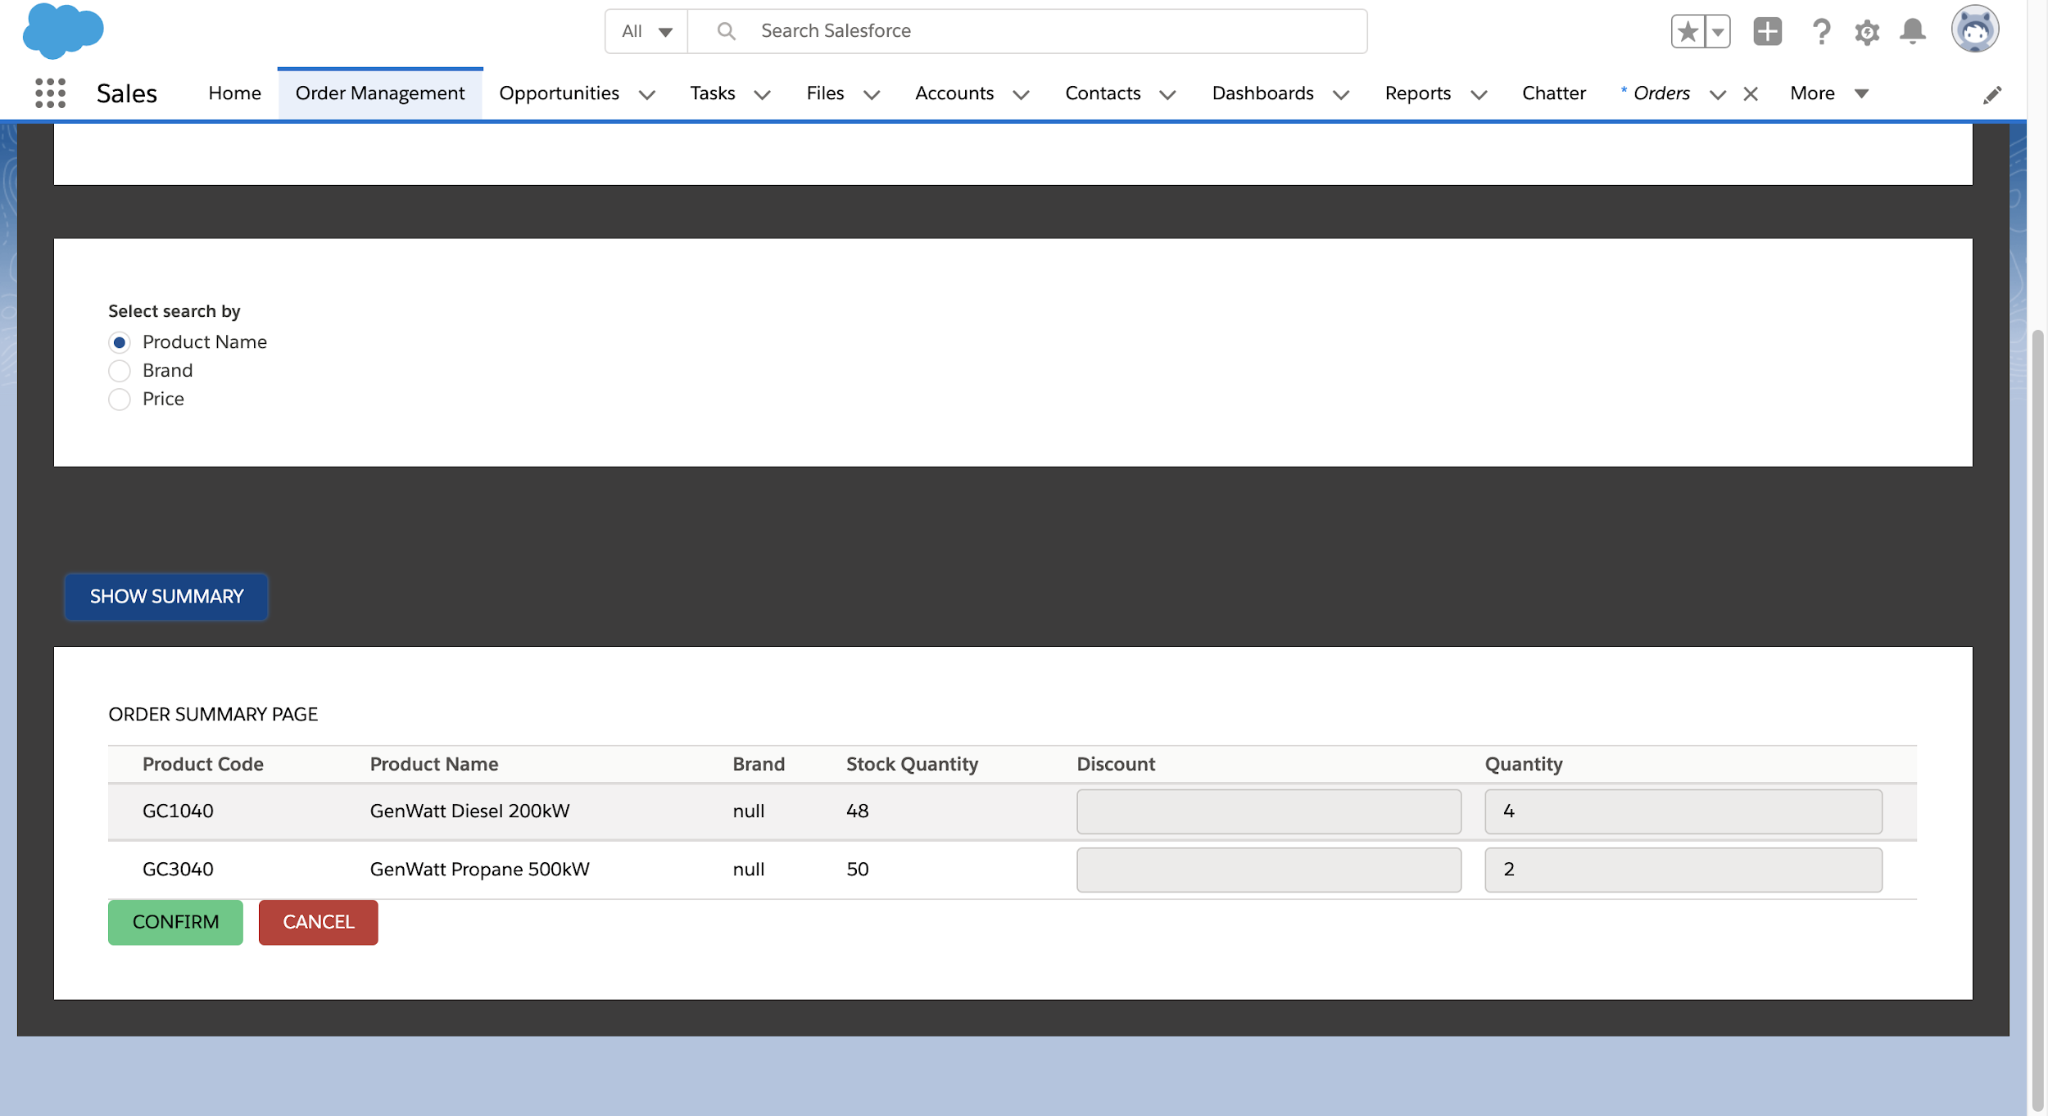

Confirming the Order:

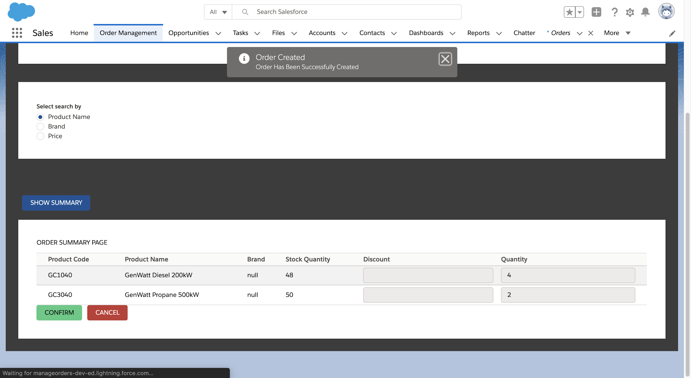

Order View Page:

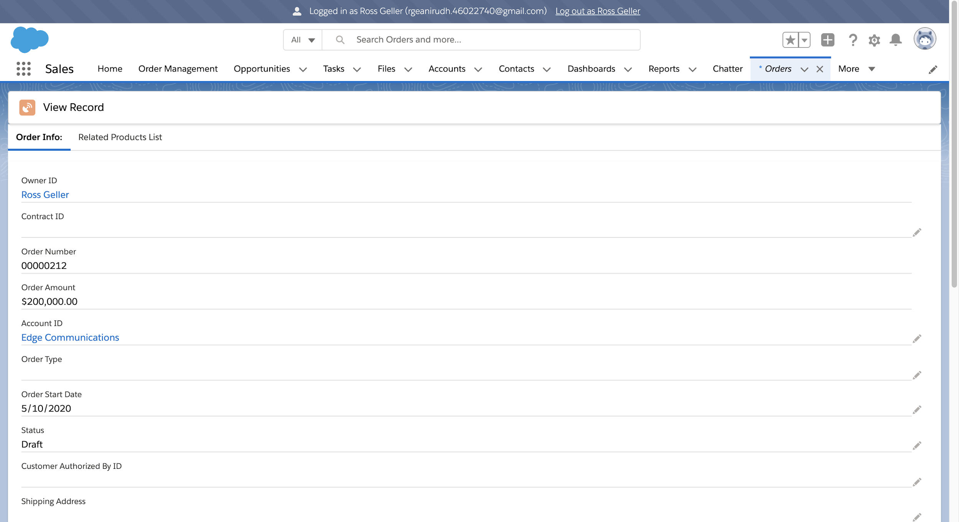

Order Waiting for Approval:

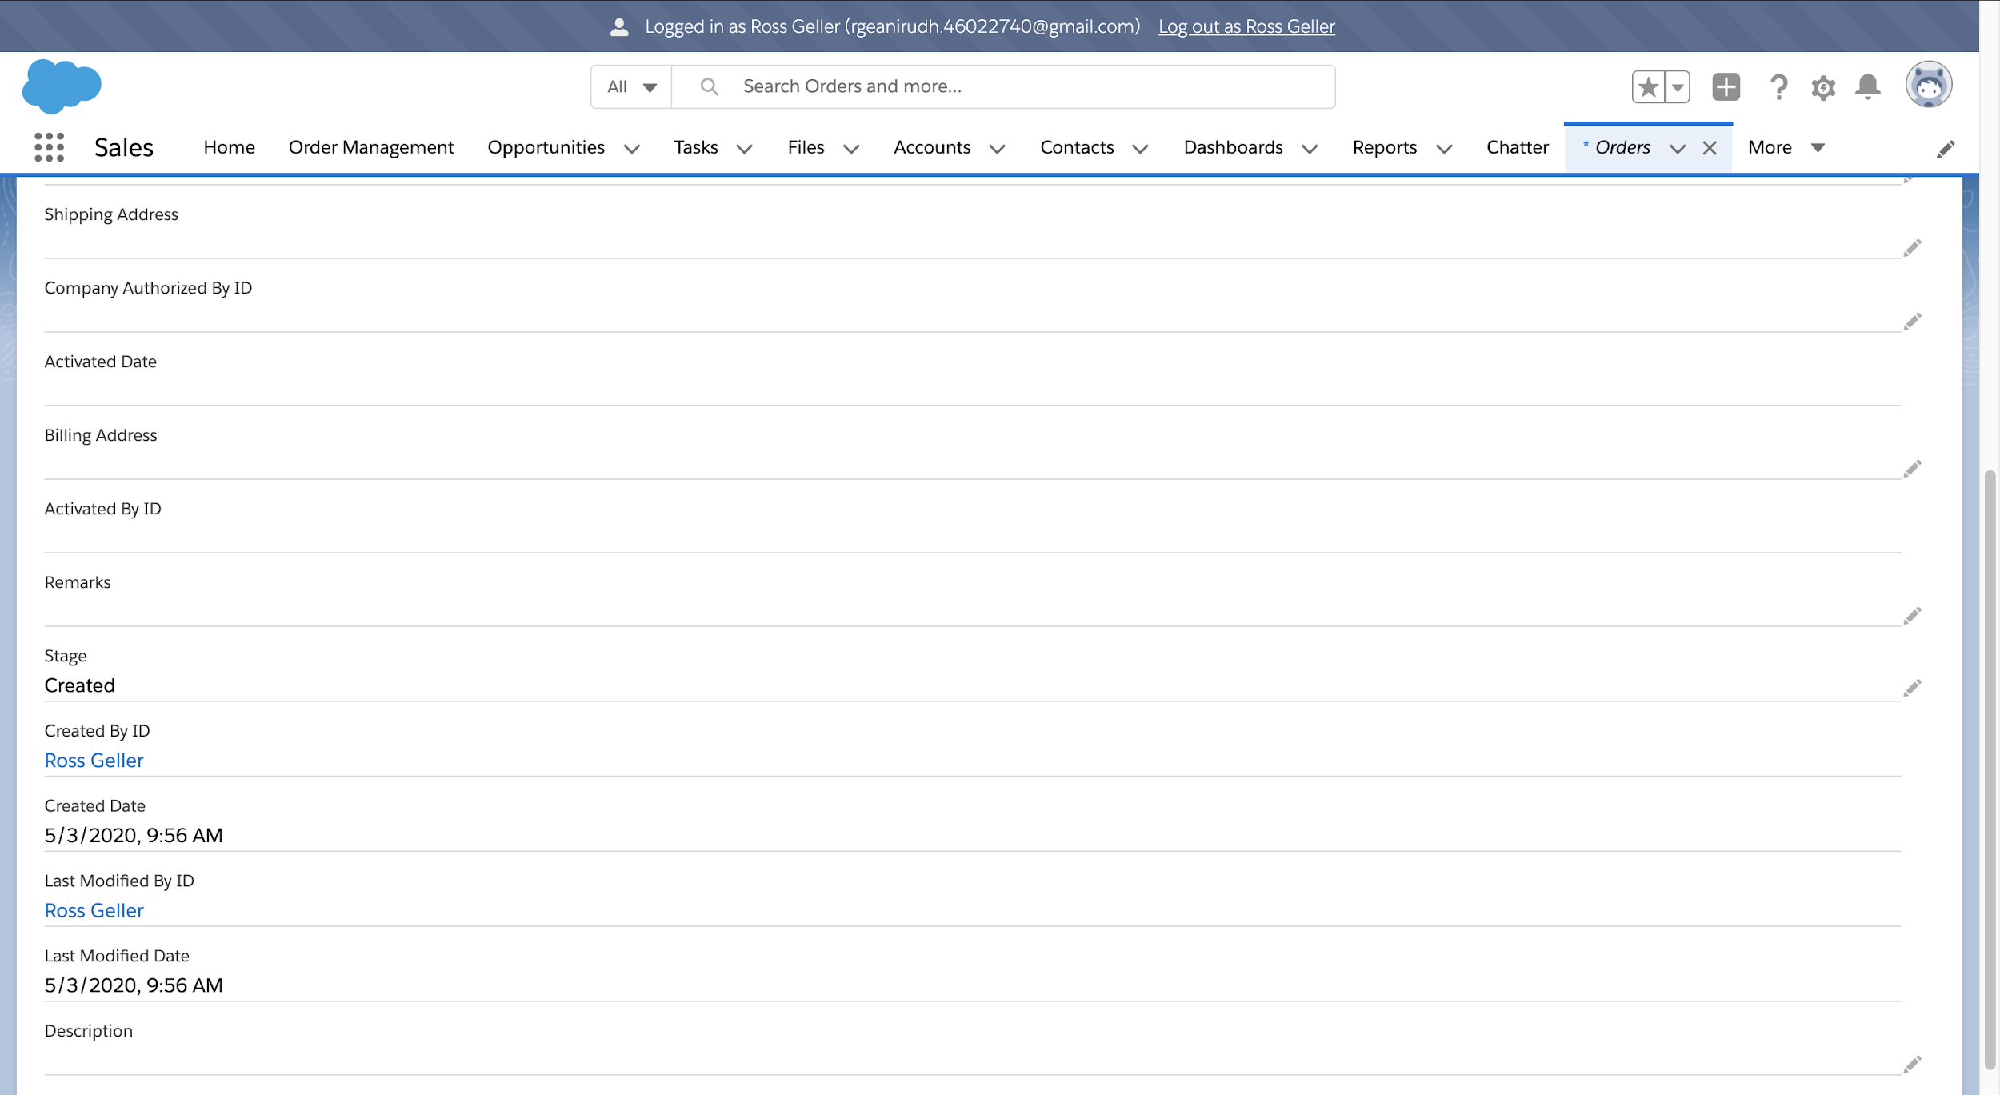

Order Products List:

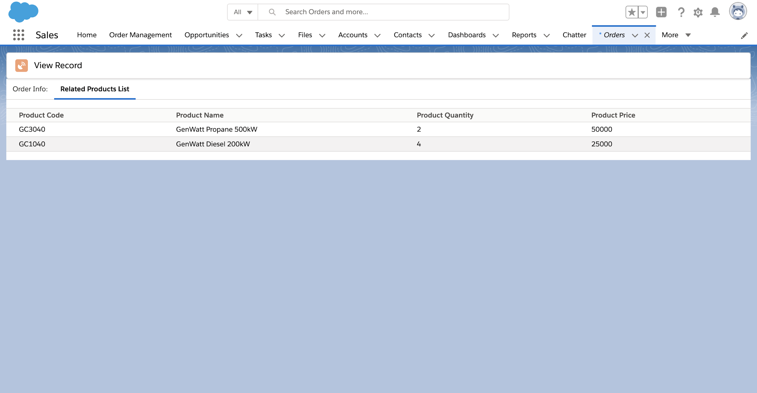

Notification for Pending Approval:

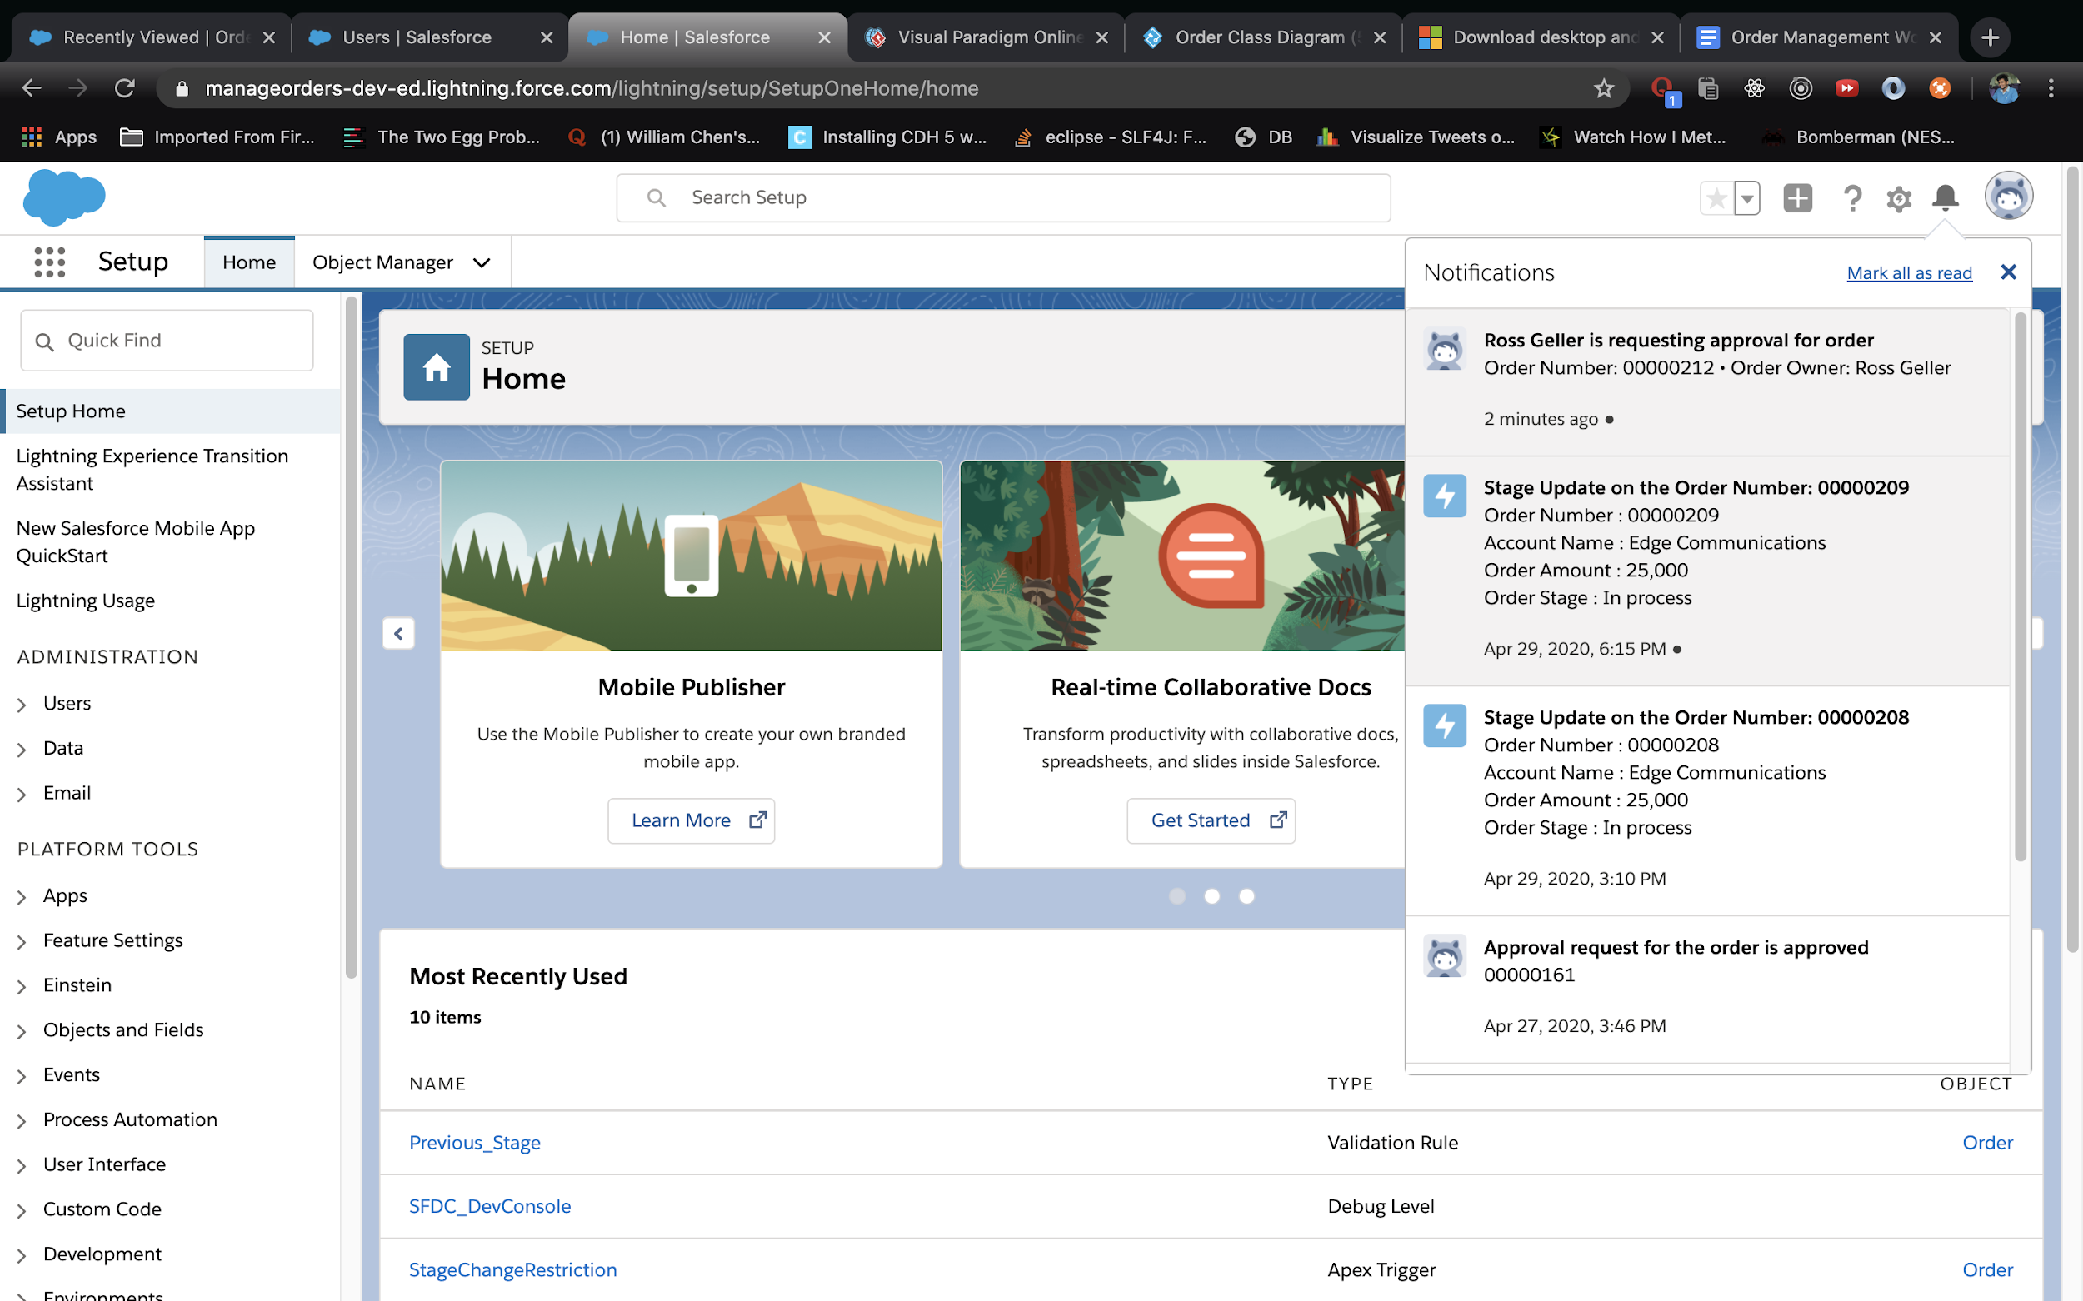

Order Approval Page:

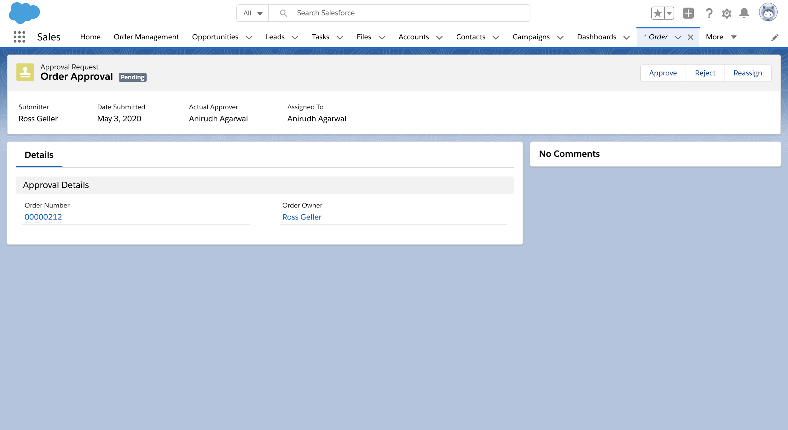

Order Approved:

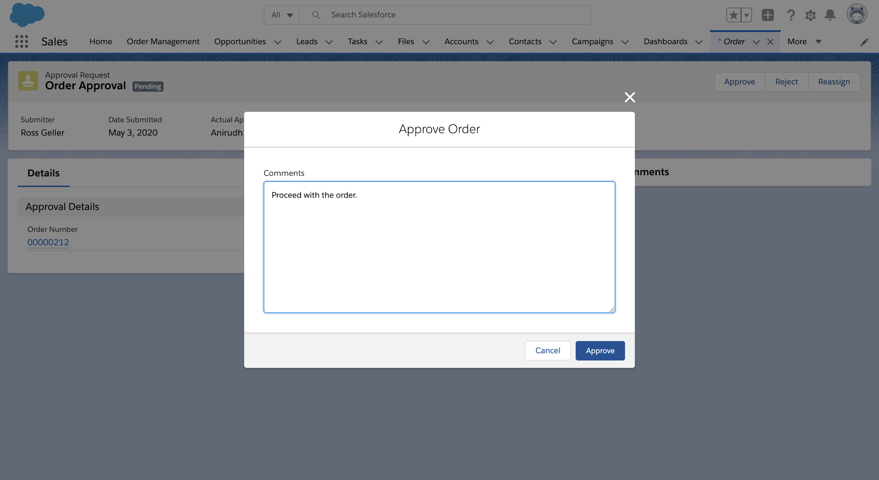

Order Stage has been Updated after Approval:

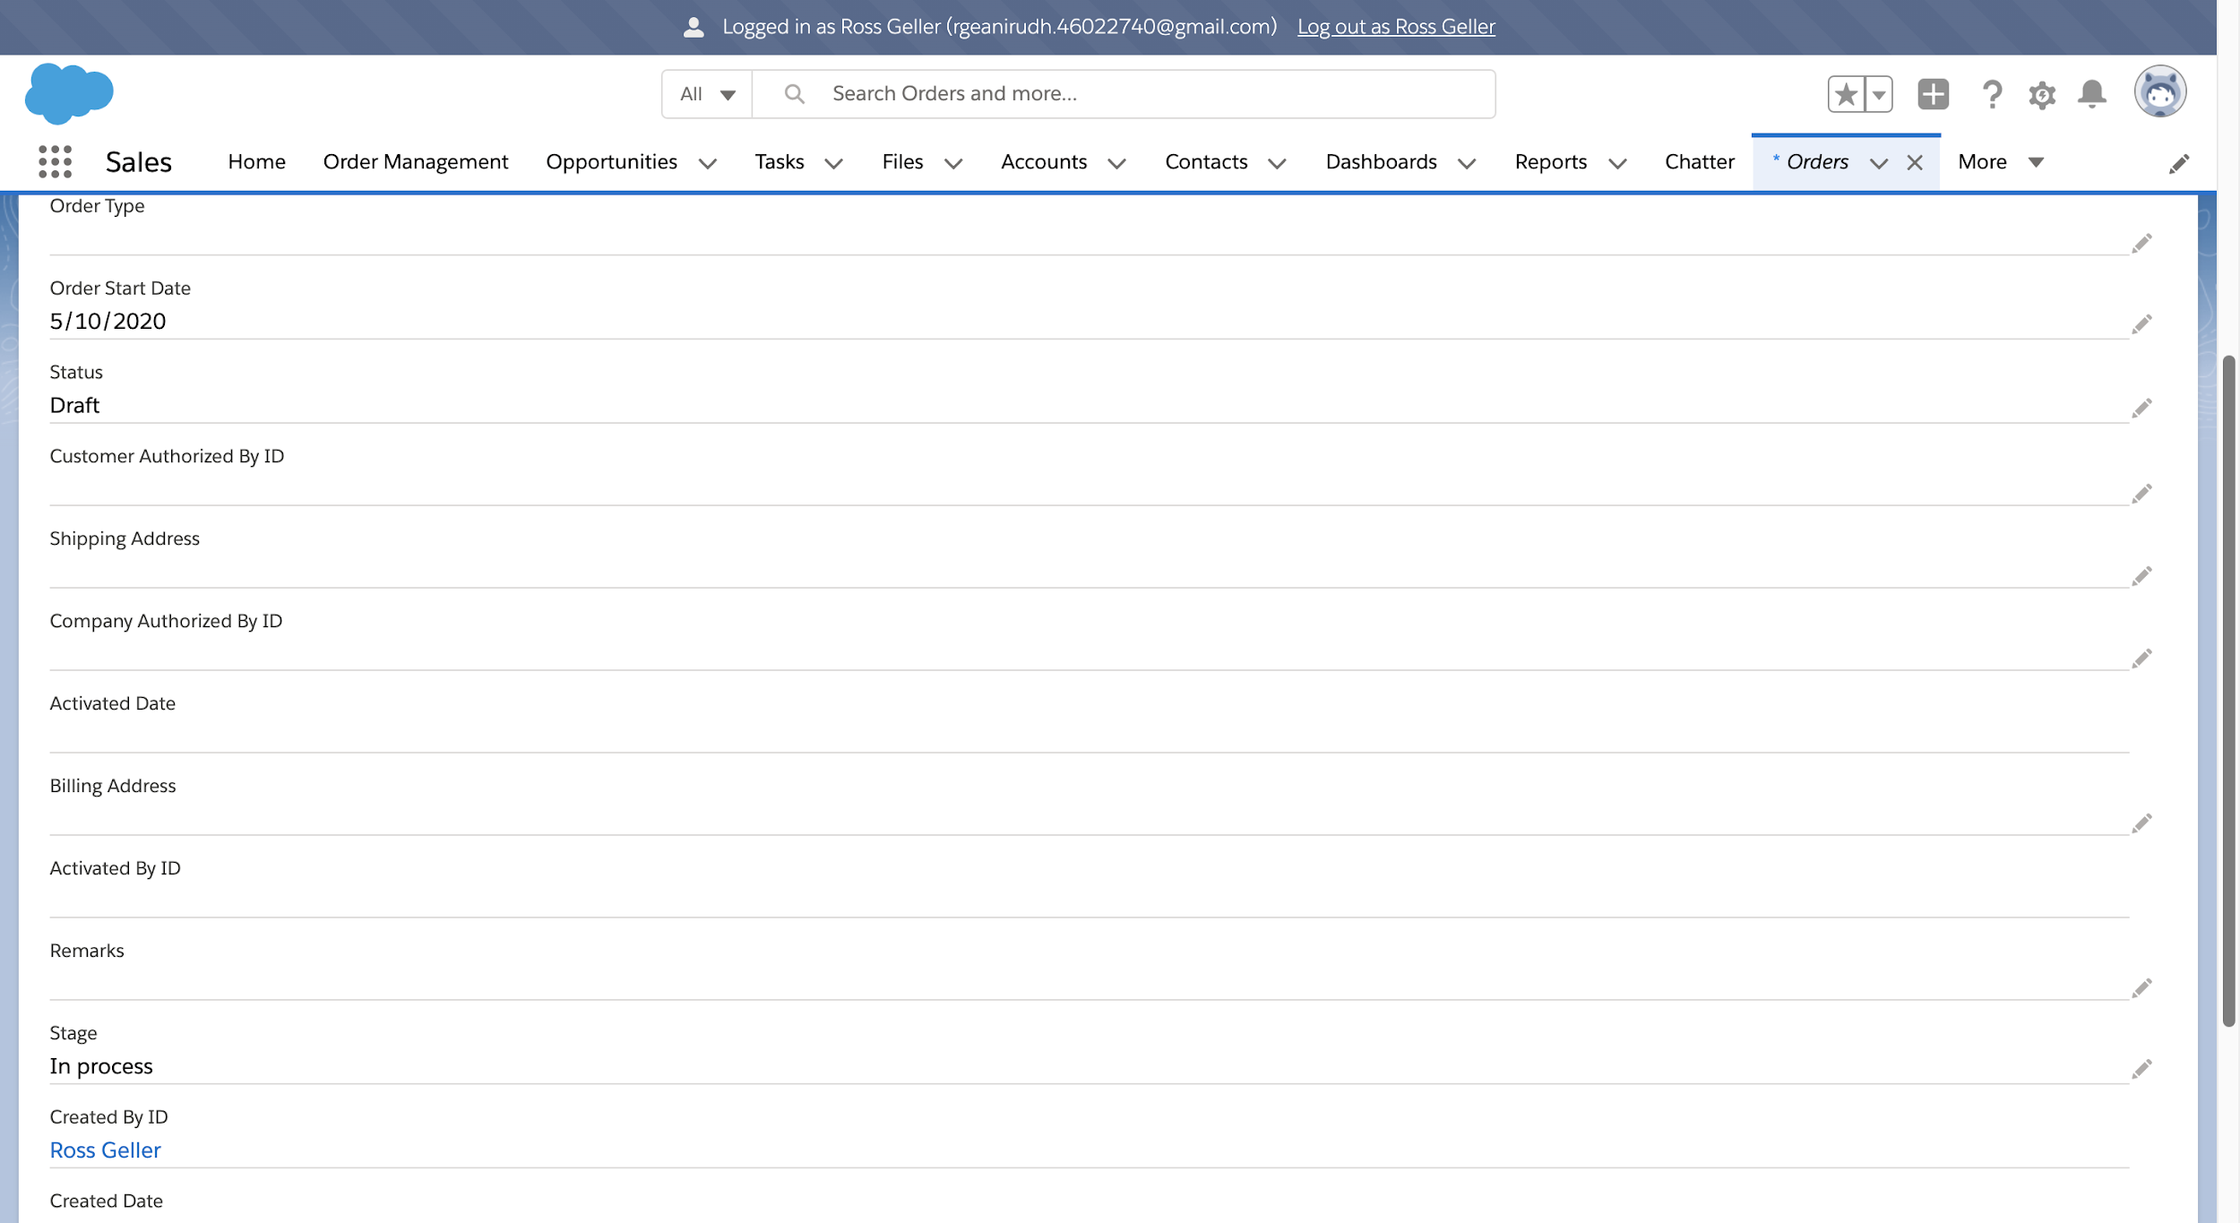

Invoice Generated for the Order:

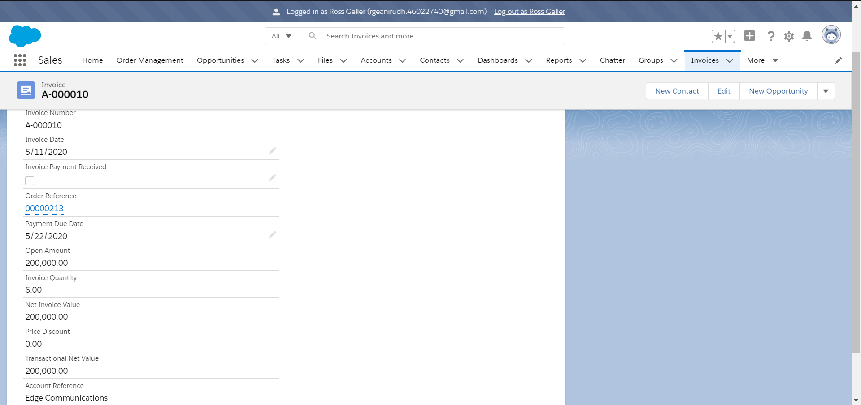

Order Stage Changed to Invoice Generated:

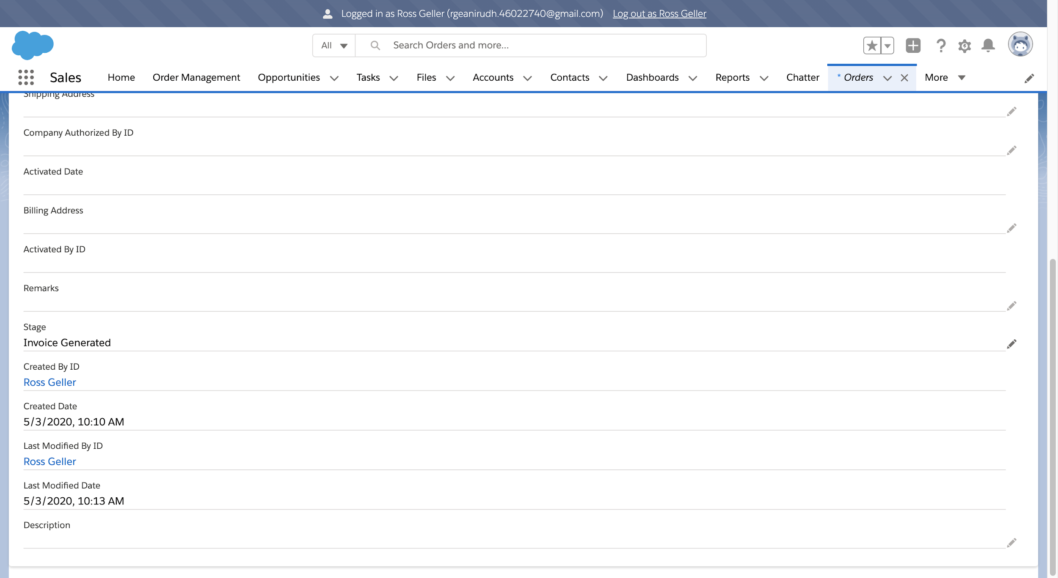

In App Notification for the Order Update:

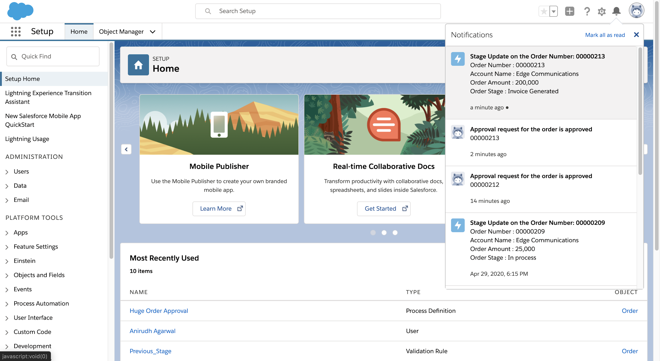

Mail to the Contacts regarding Stage Update:

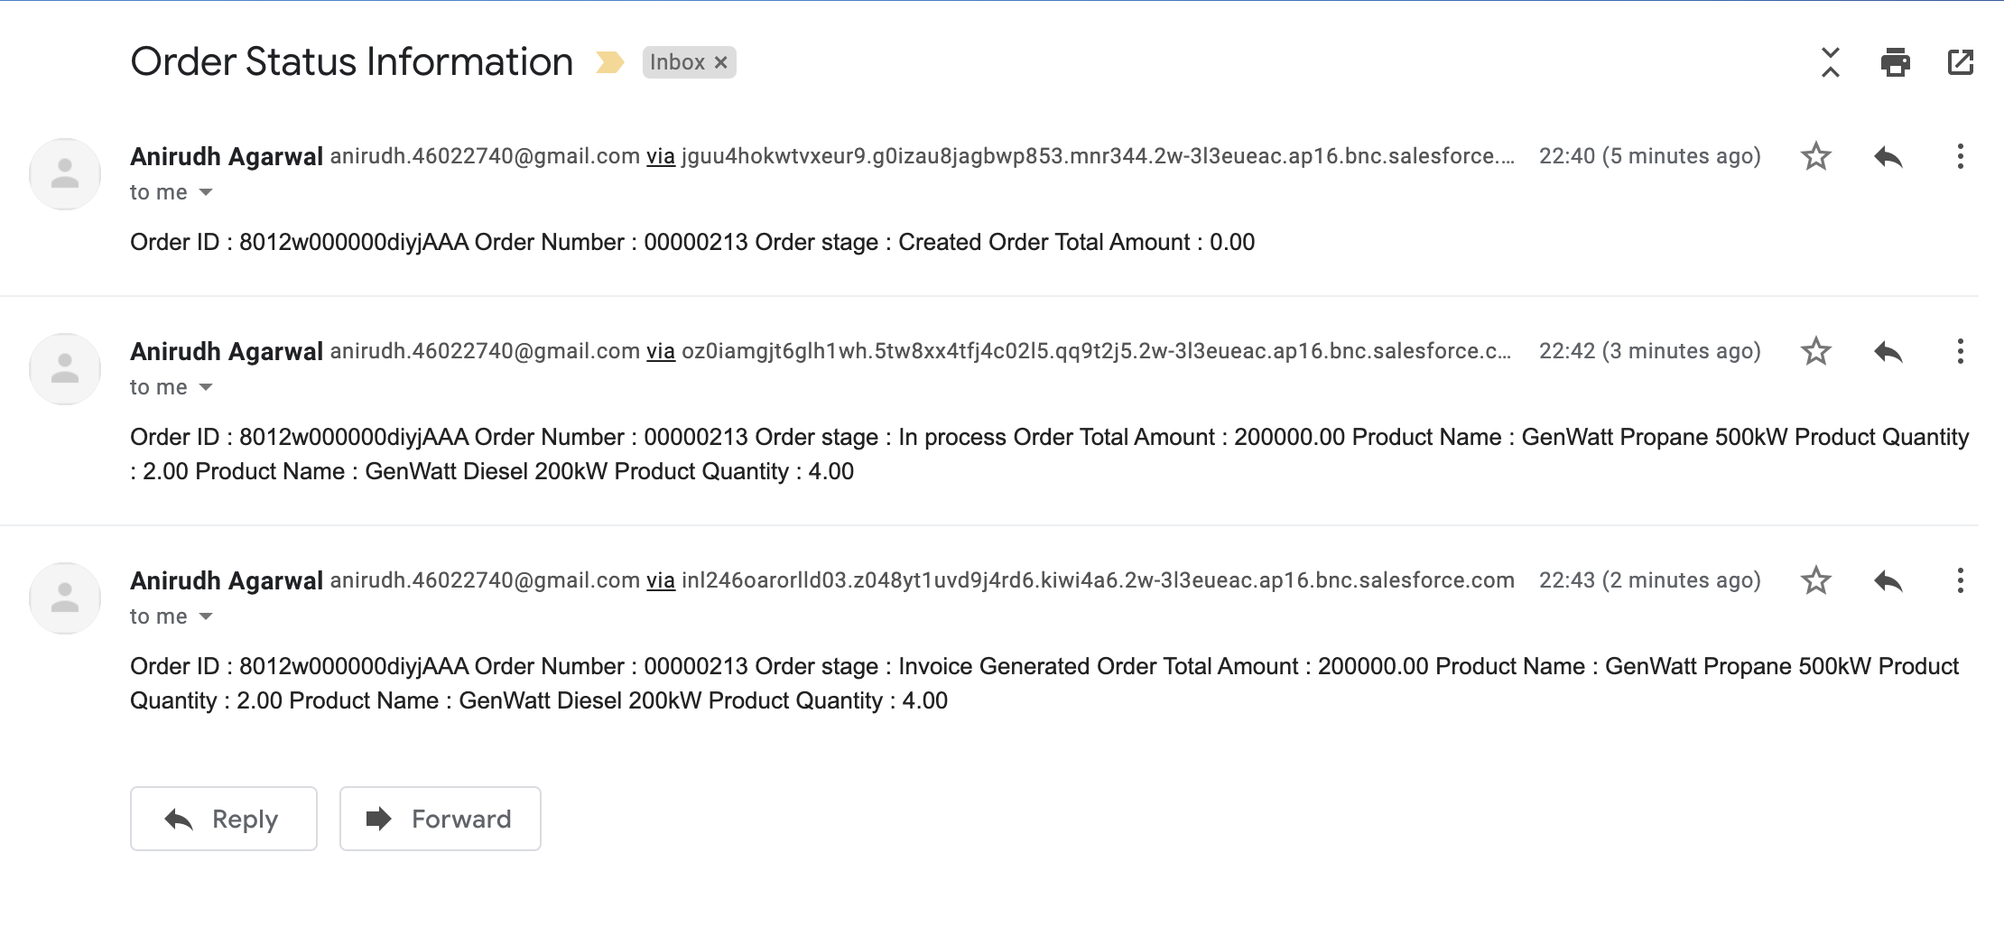

Invoice Payment Received:

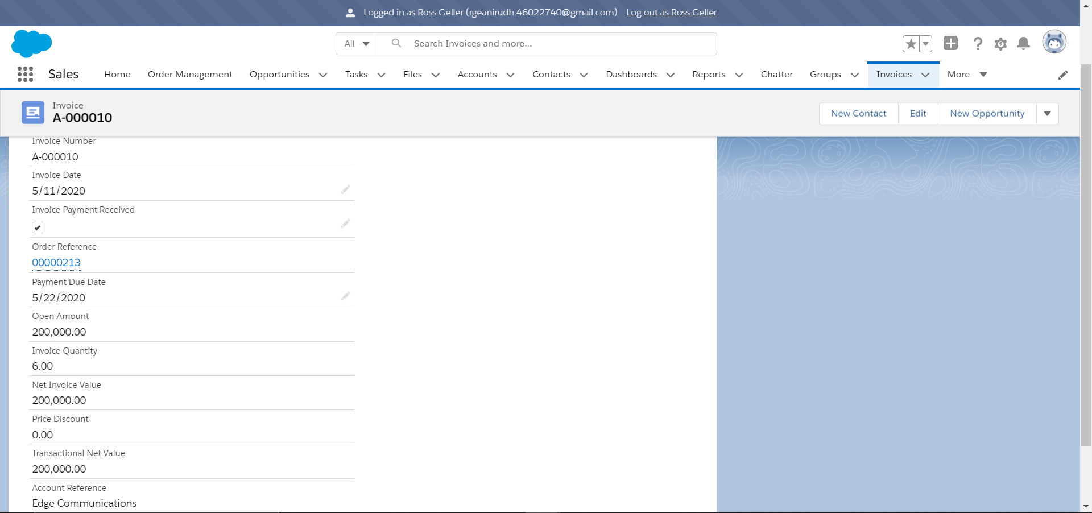

Order Stage Changed to Payment Received:

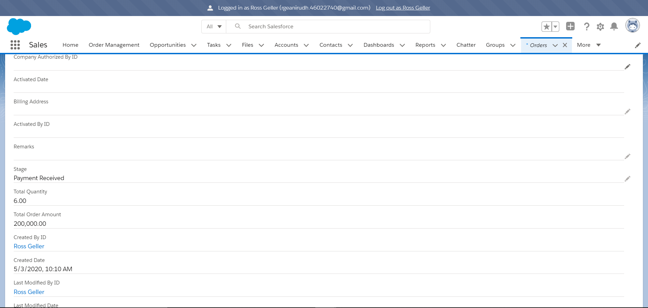

Mail to the Contacts regarding Stage Update:

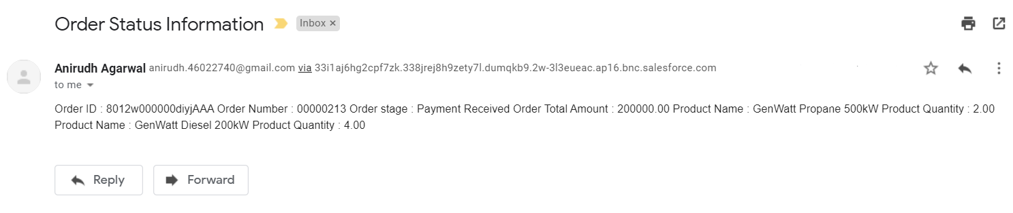

Record Edit Box:

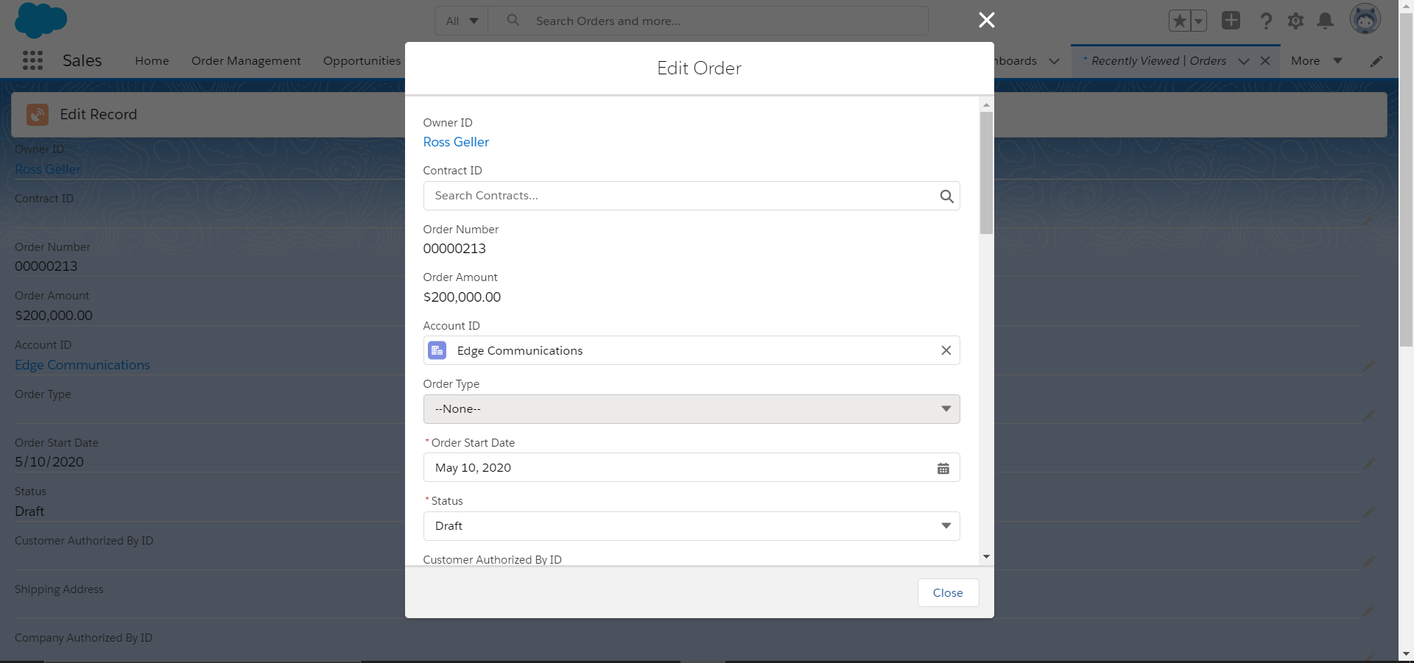

Record Data After Edit:

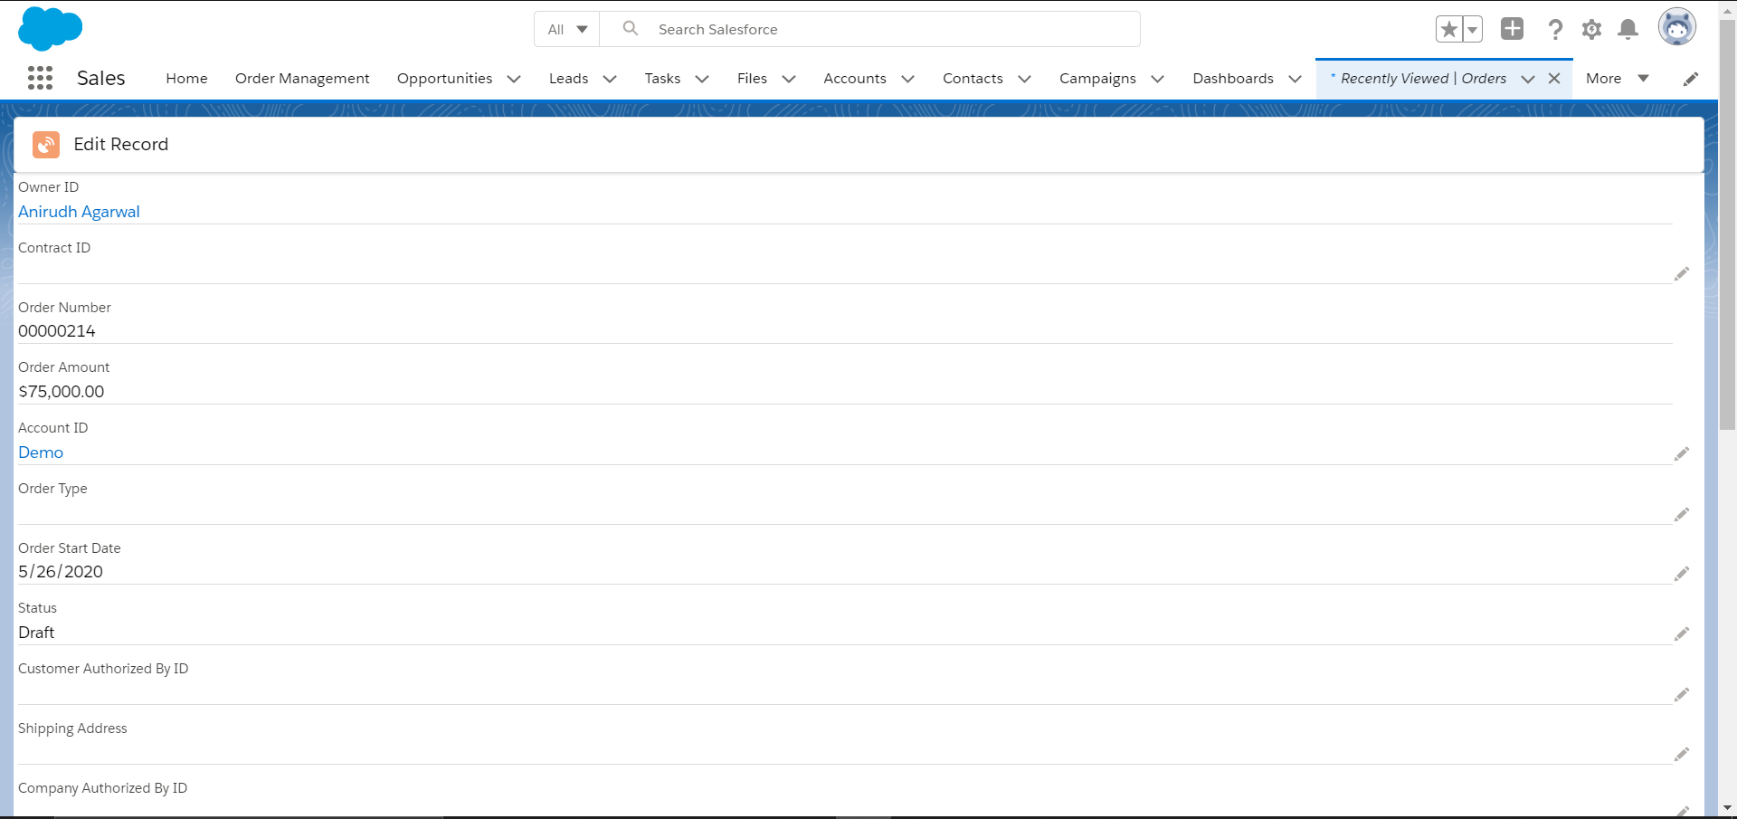

**Class and Method Description :**

1. **Ordermanage :**

Attributes :-

selectedProductsTable : Boolean

showSummaryButton : Boolean

showSearchOption : Boolean

showSearchList : Boolean

showSearchBar : Boolean

showFinalTable : Boolean

showSummary : Boolean

orderCreated : Boolean

minmax : Boolean

searchDomainValue : String

priceBookId : String

searchText : String

upperLimit : String

lowerLimit : String

recordId : String

selects : Object

selectedProductsList : List<selects>

accountOrderDetail : List<Order>

productList : List<Product2>

Methods :-

options(event):

Return the label and values for the radio button group in the user interface.

handleSuccess(event):

Return the alert message and the record Id of the order created by the user

and display the search bar.

getMinValue(event):

Return the minimum value entered by the user after opting for search by price.

getMaxValue(event):

Return the maximum value entered by the user after opting for search by price.

handleDomain(event):

Keeps the track of the option selected by the user based on which they will search.

handleSearch(event):

Fetch all the products from the database based on the text entered by the user on the search bar.

addNewProduct(event):

Add the products to the cart when users click the add button to add products to their cart.

handleQuantity(event):

Fetch the quantity entered by the user.

handleDiscount(event):

Fetch the discount in percentage entered by the user.

removeItem(event):

Remove the item from the cart.

saveItems(event):

Save the products to the Order in the database.

clearSearchField(event):

Clear the text on the search bar.

showSummary(event):

Return the order amount and order number of the created order.

handleConfirm(event):

Shows a notification of order being created and changes the order stage to in process.

handleCancel(event):

Change the order stage to cancelled stage.

1. **OrderController :**

Attributes :-

Methods :-

getRecordId() : String

Return the Id of the order created by the user.

displayProducts(String searchValue,String priceBookId,String searchDom):

Return the products available based on the search category selected by the

user.

insertOrderProducts(String selectedProducts,String priceBookId, String ordId): String

Save the products selected by the user to order products in the database

under the order created.

1. **ProductDetail :**

Attributes :-

Id : String

Name : String

ProductCode : String

Brand : String

StockQuantity : String

Quantity : String

ListPrice : String

UnitPrice : String

Discount : String

PriceBookEntryId : String

Methods :-

1. **OrderSummaryController :**

Attributes :-

Methods :-

getAccountOrder(String createdOrderId) : list<Order>

Return the order amount and order number for the created order to display it in the summary page.

updateOrderStage(String createdOrderId) : list<Order>

Update the order stage to the cancelled stage when the cancel button is pressed.

**Validations :**

1. Sales User cannot create more than 5 accounts.
   1. Trigger used on Account standard object.
2. Business User cannot be a manager for more than 2 Sales Users.
   1. Trigger used on User standard object.
3. The stage of the order cannot be modified to its previous stage.
   1. Trigger used on the Order standard object.
4. Remark is compulsory when the stage of the order is cancelled.
   1. Validation rule on Order standard object.
5. Invoice Created Date Cannot Be Before Order Start Date
   1. Validation rule on Invoice custom object.
6. Payment Due Date Cannot Be Before Invoice Created Date.
7. Validation rule on Invoice custom object.

**Assumptions :**

1. All the products are added by the support team .
2. The Status of the order should be in the draft stage.
3. Business users will be appointed as manager for the Sales user by the Support Team while creating sales users.
4. All orders will be there in the database, be it confirmed orders or cancelled orders.
5. Invoice Number and Order Number are 6-digit formatted number.
6. Users can edit the products selected only before saving the items.